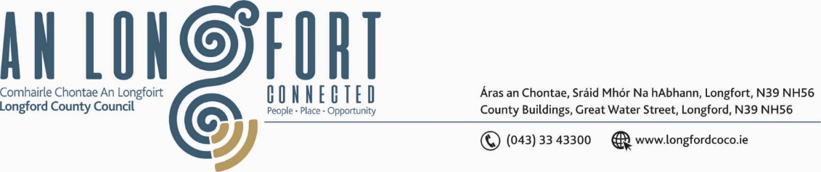

**GRANARD MUNICIPAL DISTRICT**

***Please note meeting will be held in Granard Library.***

**16 November 2022.**

**To: Each Member of Granard Municipal District.**

**Dear Member,**

You are requested to attend a Meeting of Granard Municipal District to be held in Granard Library on **Tuesday** **22 November 2022 at 3.30pm** to transact business, as set out on the Agenda hereunder.

**Yours sincerely**,

Ann Marie Mc Keon

______________________

**Ann Marie Mc Keon,**

**Meetings Administrator.**

**AGENDA**

Prayer before meeting.

**1.** Confirmation of Minutes as follows: -

1. Granard Municipal District Meeting held on the 27 September 2022 – copy enclosed.
2. Granard Municipal District Committee Meeting held on the 27 September 2022 – copy enclosed.

**2.** Matters arising from Minutes.

**3.** Declaration of Interest by Members.

**4.**  Management Report incorporating Area Engineer’s Progress Report – enclosed.

**5.** Consideration of Part VIII No 99 – Ennybegs Cyclist and Pedestrian Improvement Scheme. Report in accordance with Section 179 of the Planning and Development Act 2000 (as amended) and Part 8 of the Planning & Development Regulations 2001 (as amended) – enclosed.

**6.** Consideration of Part VIIINo 96 - Car Park at Granard, County Longford. Report in accordance with Section 179 of the Planning and Development Act 2000 (as amended) and Part 8 of the Planning & Development Regulations 2001 (as amended) – enclosed.

**7. Notices of Motions, submitted by Councillors, as listed hereunder –**

**Councillor Paraic Brady**

I call on Longford County Council to provide clarity about raised pedestrian crossing in Drumlish from playground on the Mill Road.

**Councillor Colin Dalton**

I call on Longford County Council to consider road markings from Ballinalee to Aughnacliffe and to also refresh road markings from Esker Cross to Doherty’s Cross.